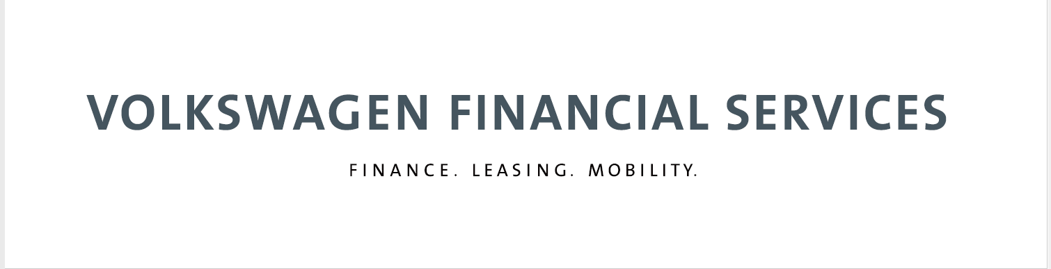
About us

Volkswagen Financial Services – a business division of Volkswagen AG. Financing, leasing, insurance and mobility: with more than 16,000 employees worldwide, with 20.5 million contracts currently on our books and in 48 markets across the globe, we make sure on a daily basis that our customers stay mobile and financially flexible.

Established in 2003, Volkswagen Financial Services Taiwan offers new car/used car finance, operating lease, finance lease, wholesale finance, insurance and service & maintenance products and services to VW Passenger Car, Audi, Skoda, Porsche and VW Commercial Vehicle customers.
Internship program
- 徵求職缺：人力資源暨行政實習生
- 實習內容：
- 人才招募規劃
- 參與人力資源相關專案
- 協助人資及行政維護作業
- 其他主管交辦事宜
- 實習期間：6個月
- 實習天數：每週至少三個工作天
- 開始實習：2022/6/20
- 實習時間：09:00-18:00
- 實習地點：臺北市信義區松高路1號16樓
- 條件要求：
- 商管、心理、人資等相關科系大學生與研究生
- 具備細心、良好的溝通能力且能獨立作業
- 熟悉Word、Excel、PowerPoint等其他分析工具者運用尤佳
- 英文能力佳，多益750分以上或同等英文標準
- 實習待遇： 依照法定基本工資計薪（2022年為170元/小時），提供勞健保
- 應徵方式：2022/5/30截止，請透過連結於104投遞履歷 https://reurl.cc/Gx5bzW
- 聯絡人資訊：Eva Hsu (02)8780-5898#671 Eva.Hsu@vwfsag.com

